Register Page:

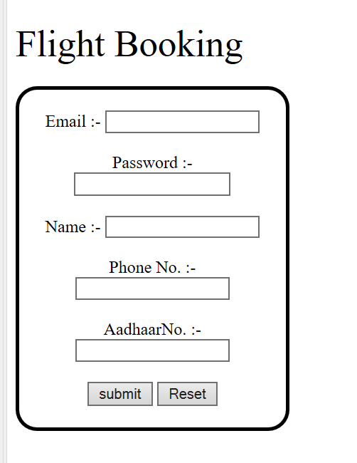

USER REGISTRATION:

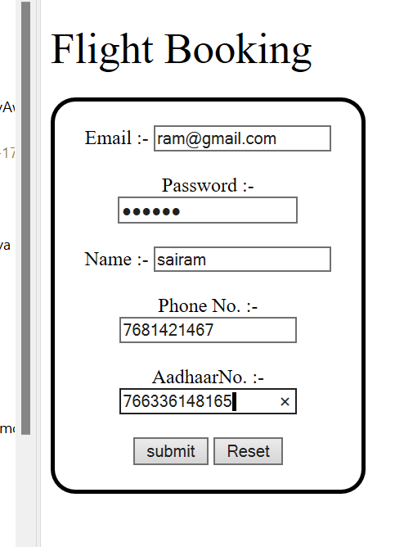

LOGINPAGE:

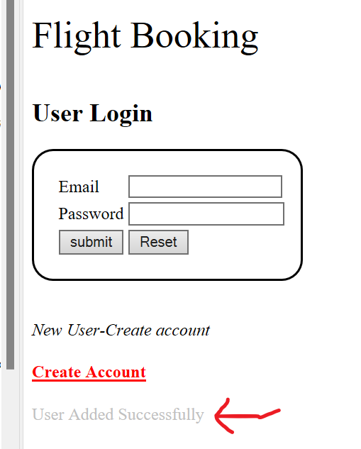

LOGIN

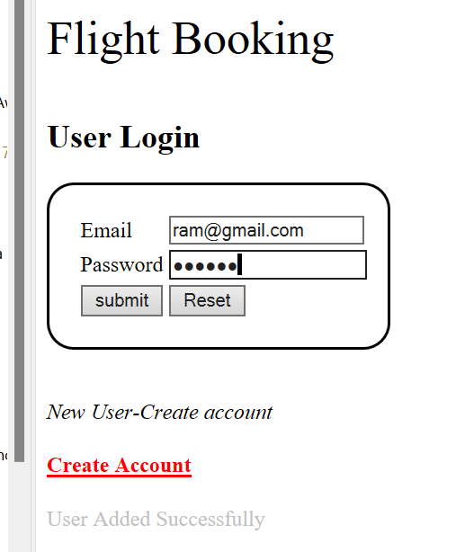

SEARCHFLIGHT

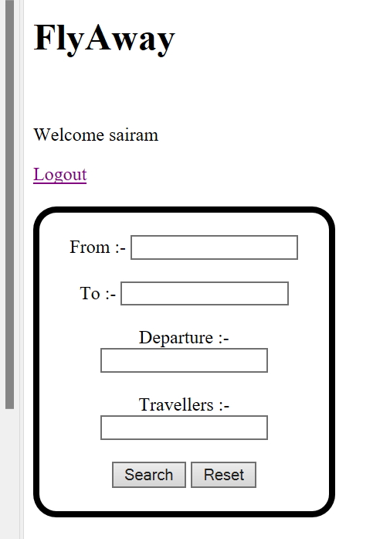

SEARCHFLIGHTDETAILS:

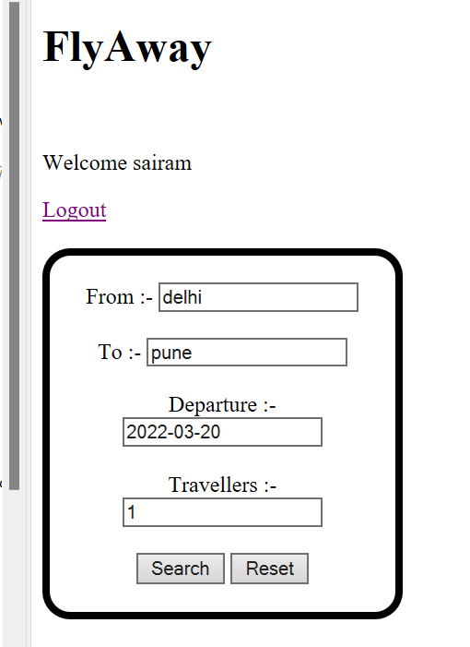

BOOKING PAGE:

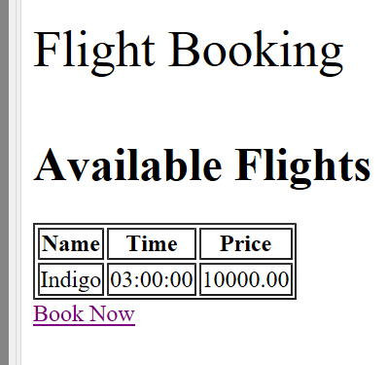

AFTER BOOKING FLIGHT:

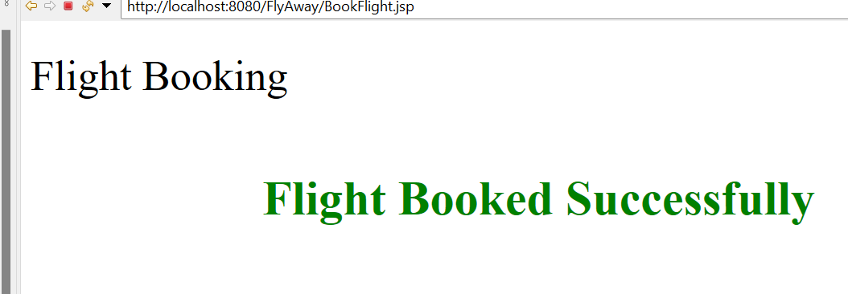

BACK TO LOGIN AND REGISTER PAGE:



**CLICK HERE TO GO BACK TO LOGIN AND REGISTER PAGE**

CLICK ON ADMINLOGIN:

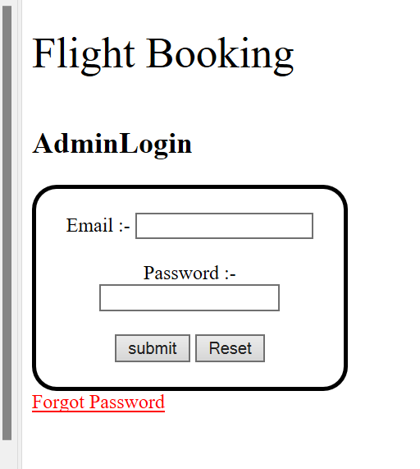

ENTER ADMIN DETAILS:

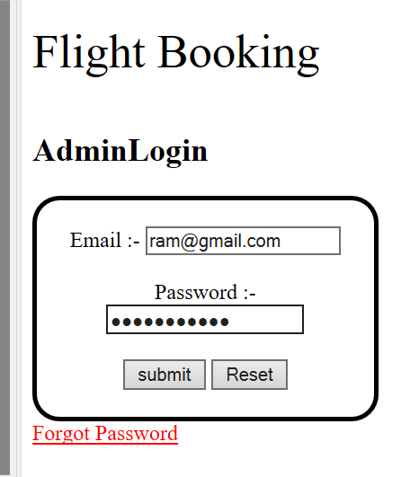

AFTER LOGIN INTO ADMIN PAGE:

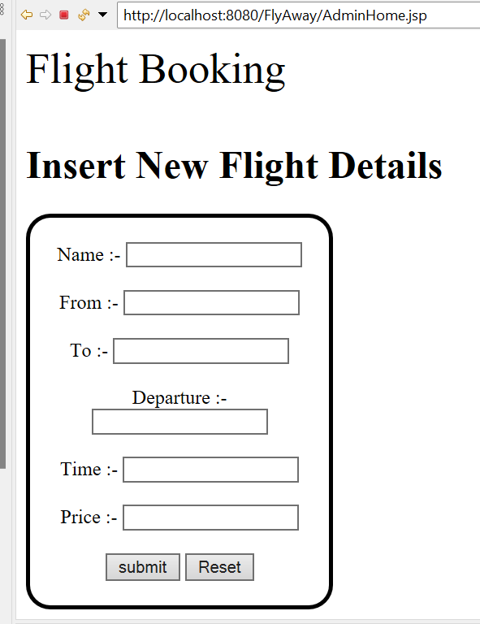

ENTER FLIGHT DETAILS TO ADD FLIGHT:

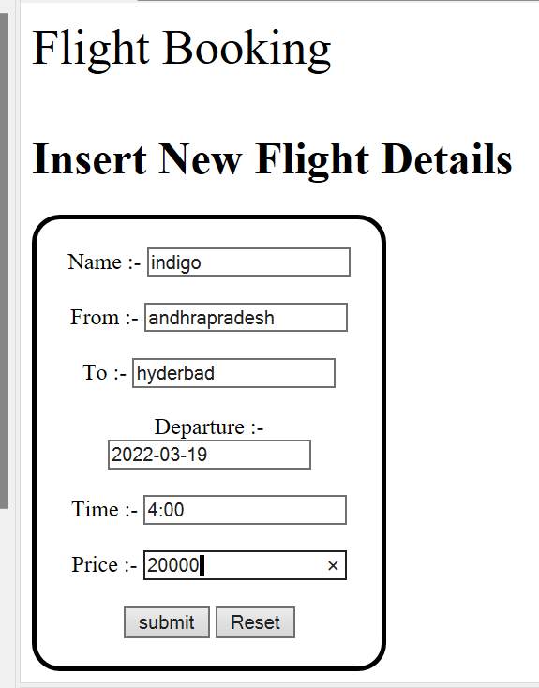

AFTER ADDING FLIGHT:

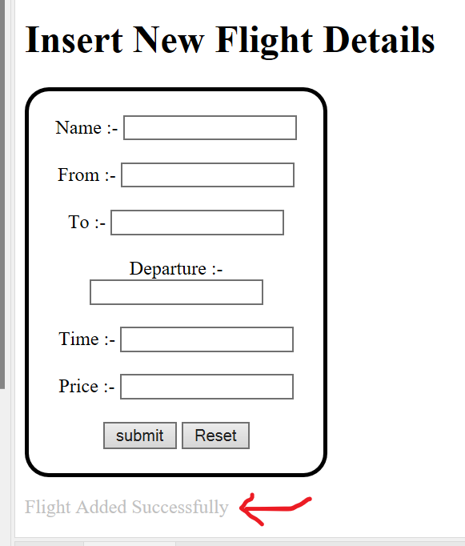

DATABASE DETAILS:

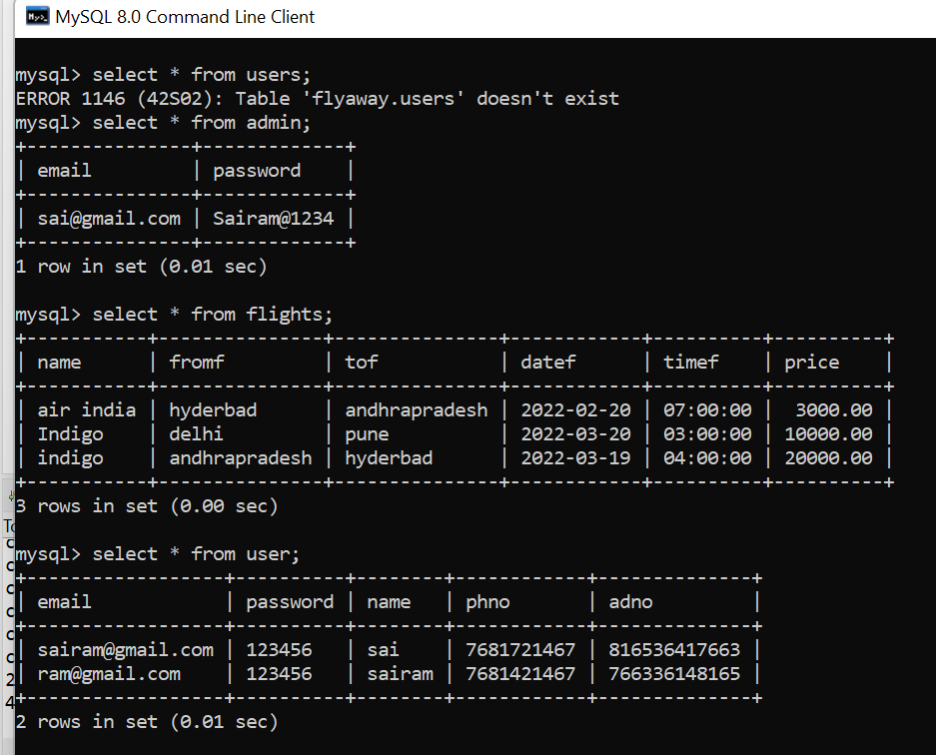”1alyt99upi@rS3

DATABASE DETAILS LIKE FLIGHTS,USERS AND ADMIN